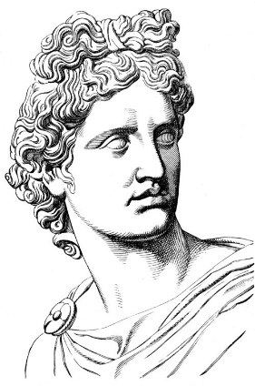
GREEK GOD/GODDESS POSTER PROJECT
DUE DATE: October 24th, 2016
Objective: Create an informative, colorful “WANTED” or “MISSING” poster illustrating a Greek god or goddess
7th Grade LA Florida Standards:
RI.1.2 Provide a summary of the text distinct from personal opinions or judgments. RI.1.3 Analyze in detail how a key individual, event, or idea is introduced, illustrated, and elaborated in a text
W.1.2 Write informative/explanatory texts to examine a topic and convey ideas, concepts, and information through the selection, organization, and analysis of relevant content. W.1.2a Introduce a topic; organize ideas, concepts, and information, include formatting (e.g., headings), graphics when useful to aiding comprehension. W.3.8 Gather relevant information from multiple print and digital sources; assess the credibility of each source; and quote or paraphrase the data and conclusions of others while avoiding plagiarism and providing basic bibliographic information for sources. W.3.9 Draw evidence from literary or informational texts to support analysis, reflection, and research.
SL.2.4 Present claims and findings, sequencing ideas logically and using pertinent descriptions, facts, and details to accentuate main ideas or themes; use appropriate eye contact, adequate volume, and clear pronunciation.
There are many different gods associated with Greek Mythology, but we are going to focus on the Olympian gods. The Olympian gods consist of twelve different gods:
- Zeus
- Poseidon
- Hades
- Hestia
- Hera
- Ares
- Athena
- Apollo
- Aphrodite
- Hermes
- Artemis
- Hephaestus

- IN CLASS: Select the name of a god/goddess. Read and research about the assigned god/goddess on the websites listed below.
http://www.greekmythology.com/Olympians/olympians.html
http://www.historyforkids.net/ancient-greek-gods.html
http://greece.mrdonn.org/greekgods/12olympians.html
http://www.ngkids.co.uk/history/greek-gods

- IN CLASS: Summarize information on the graphic organizer. CITE the resource you used to find your information. Use the website: http://www.citethisforme.com/
- AT HOME: Create an 8½” x 11” poster. WANTED or MISSING poster must include:
- Name of the god/goddess, clearly shown.
- Relationship to Zeus, if any.
- Image of the god/goddess properly attired for a classroom presentation, and equipped with objects often associated with the gods in general or that particular god/goddess.
- Other images/symbols associated with the assigned god/goddess.
- A neat, brief, type written paragraph telling the story associated with the assigned god/goddess, written in your own words.
- Use of color as symbolism. Ex: red = angry, fury; blue = calm, serene
- BRING completed poster to class BEFORE or ON October 24th – Don’t procrastinate. This counts as a PROJECT grade.
- Present the poster to the class:
- Show picture of god/goddess
- Tell class the name, myth around god/goddess, and 2 other interesting facts
Student Name: ___________________________________ Class Period ____________ Date ______________
Name of god/goddess: ________________________________________________________________
Alias or nicknames: ___________________________________________________________________
Powers/areas of control or influence?

Physical description/photos/drawings?

Personality traits (EX: STEAL-What does your god/goddess say, think, effect on others, actions, looks?)

Known family, associates, partners in crime?

Significant actions/crime/dangerous or last seen?

Presumed dangerous? Why?

Additional interesting information (Ex: favorite city, items/symbols/holidays association)

