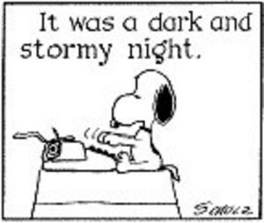How do you

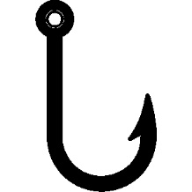“HOOK”

your readers?

The **HOOK** catches the reader’s attention; introduces the subject matter and tone of your essay; and sets up, or leads into, your bridge and your thesis statement.

Types of HOOKS

**An Amazing or Unusual Fact**

During the Apollo 11 mission to the moon, the astronauts spotted a large object flying in the same direction.

**A Description**

Reports of flying saucers, flashing lights in the sky, strange burn marks on the ground, and men in shiny spacesuits have continued over the years.

**A Quote**

“The recent explosion in UFO reports has more to do with the increase in UFO study groups around the country than it does with an increase in alien visitors,” said Rutkowski of Ufology Research, Manitoba.

**A Question**

Is there life in outer space?

**A Bold Opinion**

We are not alone in the universe.

**A Statistic**

Almost 75% of all UFO reports turn out to be a weather balloon, meteors, or the reflection from clouds and ice.

Description

Amazing or unusual fact

Quote

Bold Opinion

Question

Statistic

