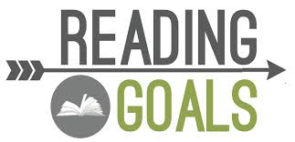
 | MY GOAL  How many words will I aim to read  this month? | TOTAL  How many words did I read? | GOAL  Did I meet my Goal?  (Y or N) | SCORE  %  Based on Rubric | RUNNING TOTAL  How many words have I read so far this year?
AUG
SEP
OCT
NOV
DEC
JAN
FEB
MAR
APR
MAY

KEEP THIS GOAL CHART IN THE READING SECTION OF YOUR FOLDER AT ALL TIMES

